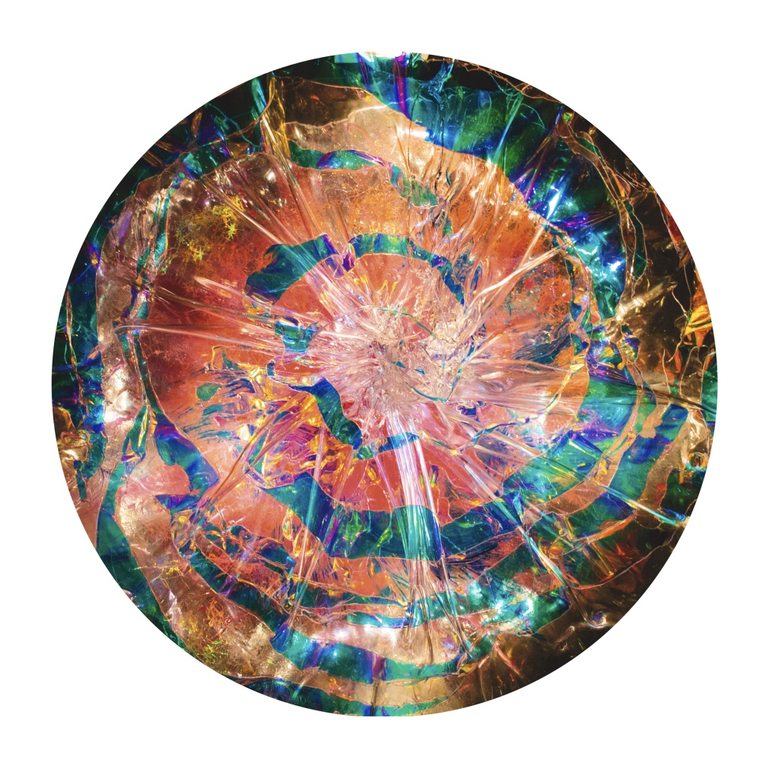Creative Days:
Group Work for Team Building, Businesses and Students
2024

www.lornacarmenmcneill.com
lorna@lornacarmenmcneill.com
+44 (0) 07967-978821

Images below are artwork produced by teams on the courses
After years of experience of workshop facilitation in different contexts, I headed up creative team building services at the Art Academy from 2015-2016. I now offer a range of team building, development and creative day options for groups, students, businesses and charities. These can be adapted or created bespoke for your individual needs. A session could help your team in terms of:

Communication…increase effectiveness, build trust, create unity
Values and vision…explore and express your organisation’s core values
Creativity…develop creative thinking, individually and as a group
Team cohesion…work together towards a common goal
Fun days…unwind, motivate, inspire and reward
Creativity and Art are one of the most important joys in in terms of the fun of making and creatively expressing yourself. It can help you to feel truly and meaningfully alive. The power of unlocking creativity for both individuals and teams is undeniable. For businesses this can be hugely valuable, both to strengthen your team’s communications or to re-ignite your vision and ability to innovate. Creative practice can also enable examining particular issues or even effecting change.
Workshops are offered at your site, in museums eg Tate Modern, or at a central location.
Previous clients include: John Lewis, Cherie Blair Foundation, Unilever, Christian Dior Couture, Social Mobility Foundation, Frank Reynolds Artchitects, Kensington and Chelsea Social Council, IP and Science MarkMonitor, Close Brothers, Euroclear, SWD, Ørestad Gymnasium, Copenhagen, Cass Business School and City University and others
​
“I just wanted to reiterate the great time that we all had on Tuesday, and how much that really was down to you putting us all at ease and creating an environment where everyone felt comfortable enough to get involved and express themselves. The consensus from everyone was what a great day it was and how relaxed everyone had felt, even those of us who had scepticism (myself included)!! I really think that you played a huge part in that, so thank you ever so much." Unilever
​
"The day was fun and productive; we came away feeling both energised and inspired by our team’s creative potential! We really appreciated all the detailed and helpful communications that were received prior to the event; Lorna was always on hand to accommodate any questions or concerns we had leading up to the day. We felt confident that all our goals and objectives would be incorporated into the day’s activities.

On the day, our team enjoyed the activities and were overall very engaged and enthusiastic. The length of each activity was ideal, not too short and not too long. The warm-up games were a fun and humorous way to get us into a “team-work” mindset. Most importantly, the activities were hands-on and inclusive and something that everyone could do, no matter their skill level. Teams were also small which meant that people could really get to know each other on a more individual basis. The art tutorial offered prior to the Abstract Painting activity was especially helpful; because of this we didn’t feel “thrown in” to something out of our depth. I wouldn’t hesitate to recommend this to any organisation looking for something different, where your team can stretch their creative muscles whilst getting to know each other on a more individual level. "
City University of London, Marketing and Communications Team Away Day
Create exciting group artworks

Abstract Painting - exploring abstract art techniques and approaches – apply to set theme or theme of your choice.
The class/team starts by learning about abstract painting, they then learn techniques
themselves by doing some simple exercises based on these principles. The tutor
takes them through the exercises step by step, so no previous experience or aptitude is required. Each person or group then goes on to create their own ‘abstract painting’ based on a given theme, such as ‘ the values of the organization’ or it could be something lighter and non-work related such as music, poetry or literature. The final works can be designed to show in the school or workplace or taken home and the results are always amazingly creative and can be exhibited with great pride! This exercise is perfect for group to develop a growing understanding and appreciation of each other. The exercise also works very well in exploring the underlying qualities of the team, of core values, a strategy or whichever subject is chosen as the theme.

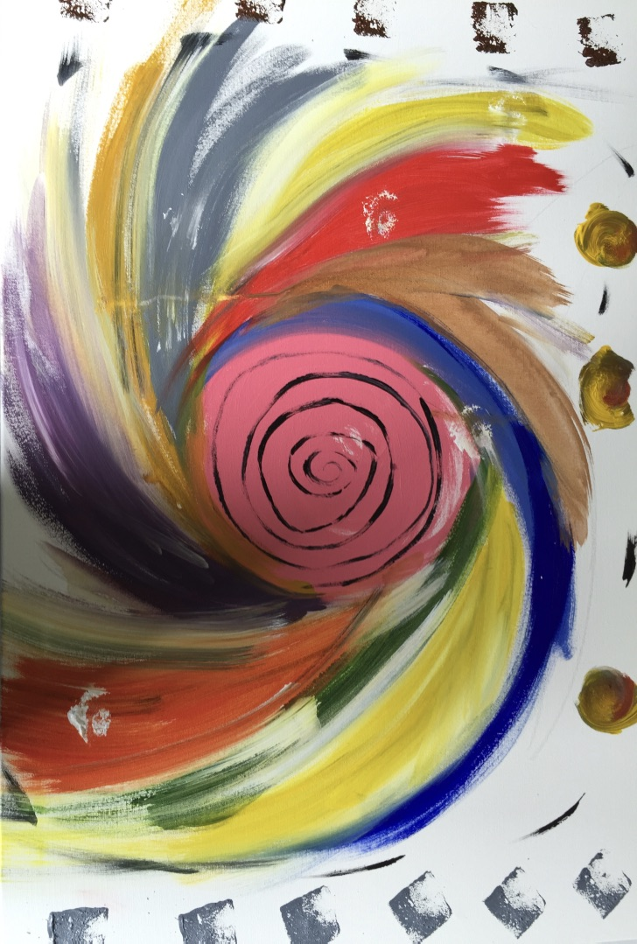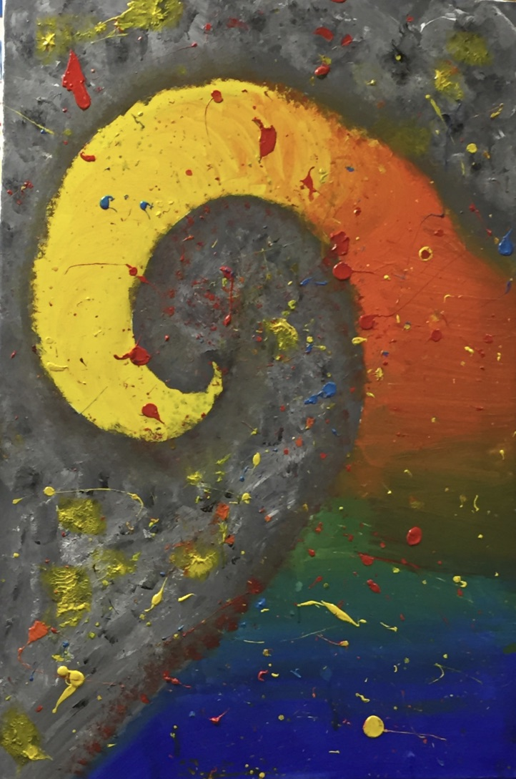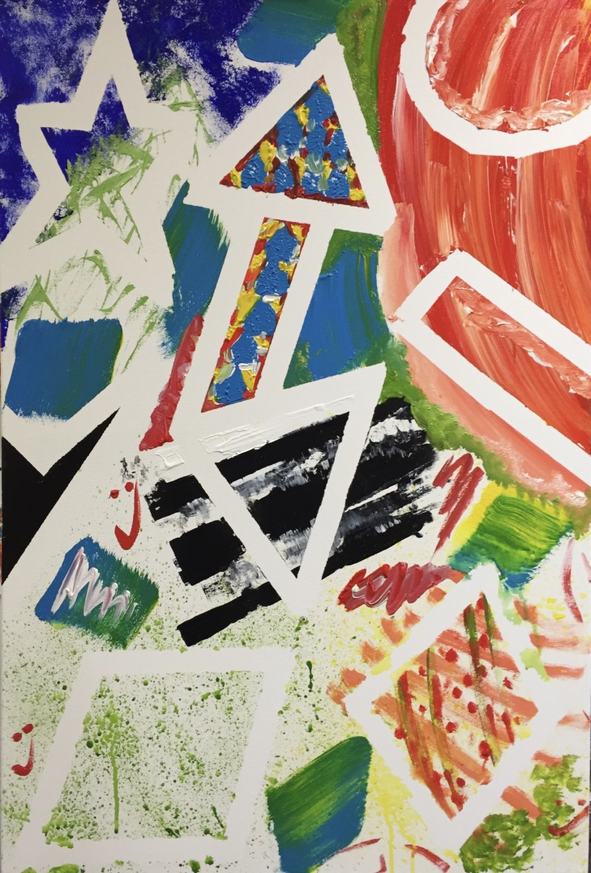

Creative abstract Sculpture
The class/team starts by learning about creative sculpture, taking inspiration from past
and contemporary artists. They then learn techniques themselves by doing some
simple exercises based on these principles using clay, wire, coloured paper. No
previous experience or aptitude is required as each step is guided by the tutor. The
group then goes on to create their own ‘abstract sculpture’ based on the chosen theme,
or values. This exercise is huge fun and very creative as everyone is working together and has to communicate with eachother to make the final piece. It is perfect for group bonding and for the group to develop a growing understanding and appreciation of each other for improved cohesion. The results are always amazingly creative!
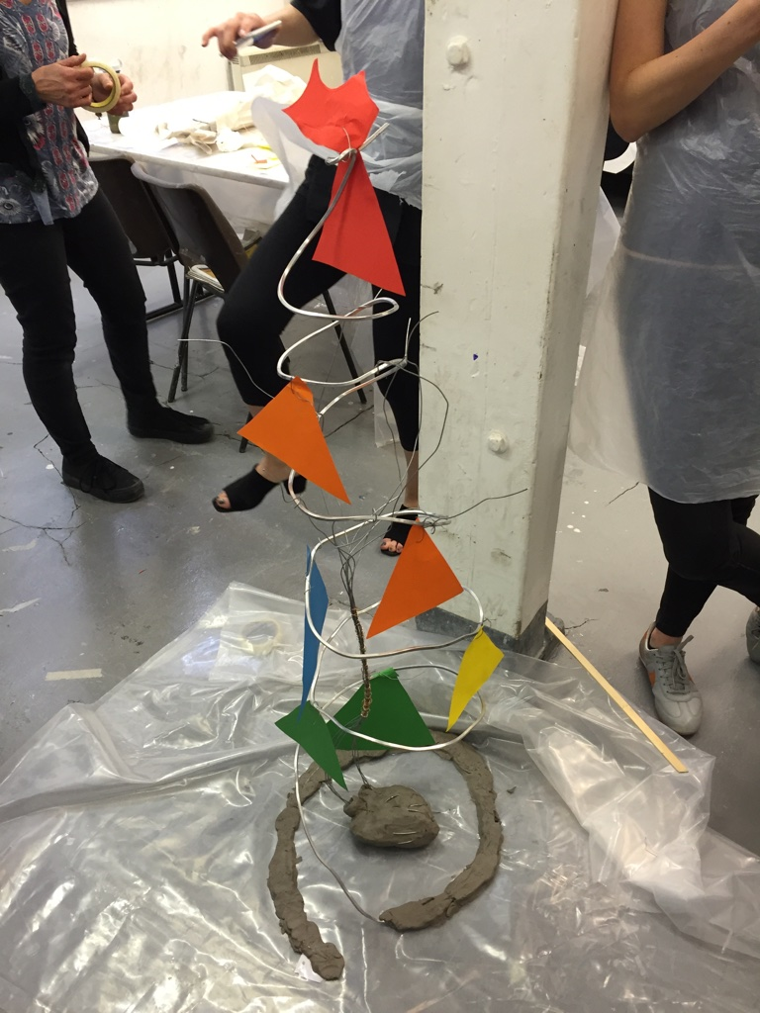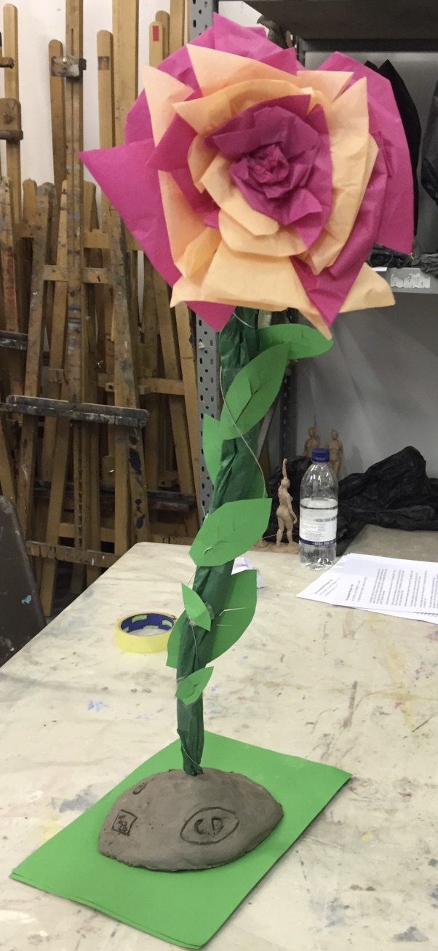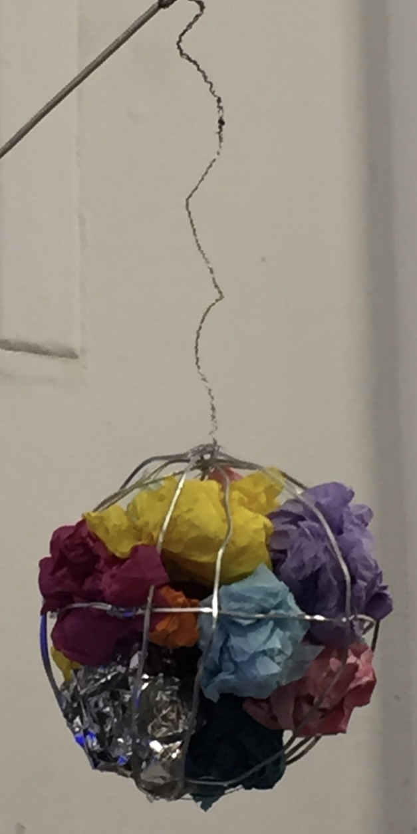

Face to Face
Fun, get your hands dirty, and very funny. It is amazing what people can achieve in a short time. The session starts with learning about different approaches to portraiture, inspired by great artists of the past and present. Participants pair up, talk to each other, find out about each other and then sculpt each others portraits realistic, abstract, or with a little imagination its up to them. At the end they share what they have found out about each other with the group A photographic record can be made of each piece Or more straightforward portraiture can be done using a mode.
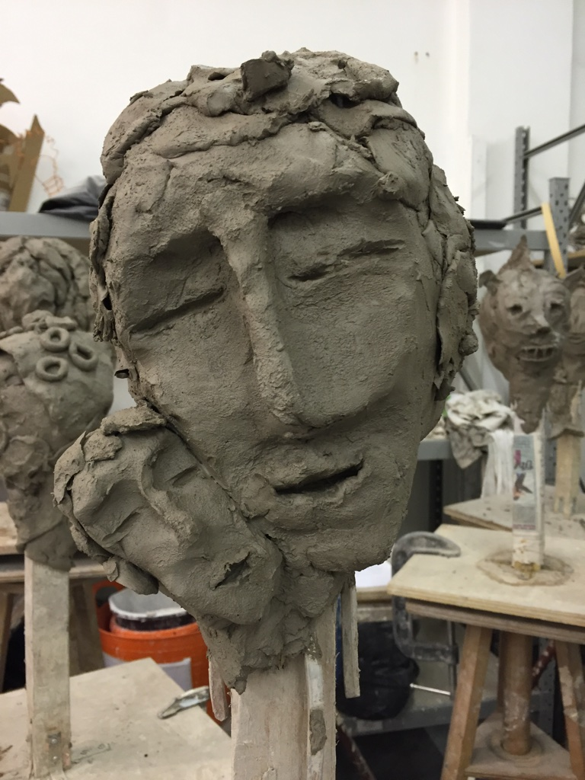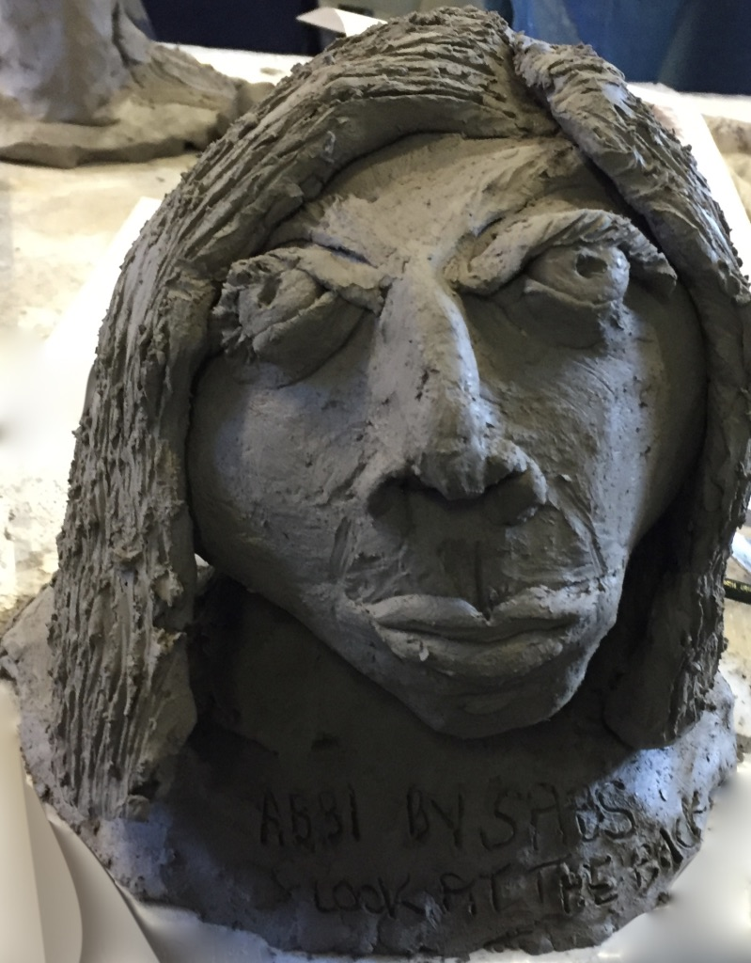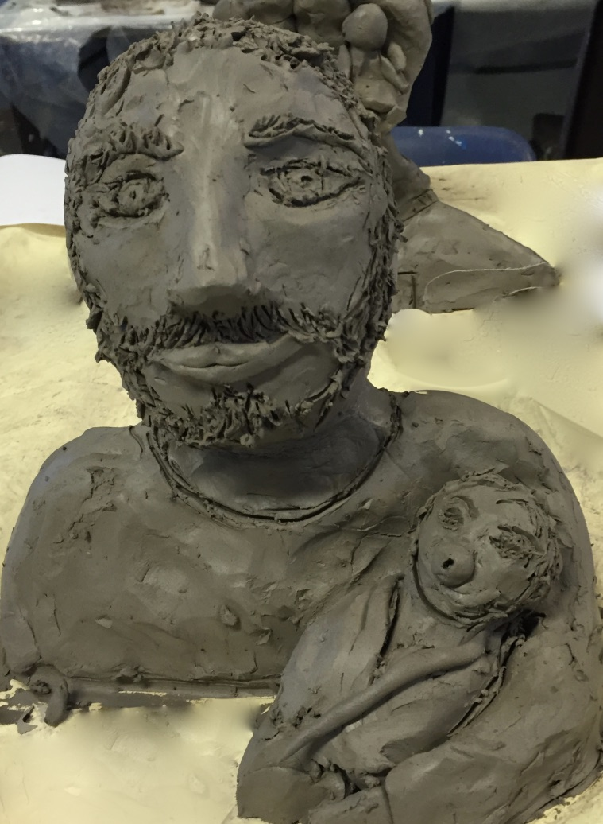

Fabricated sculpture
This is a brilliant process where the students find and select a series of objects and
then make a mould press in clay to cast a series of plaster parts, which can then be
stuck together to create a whole series of semi abstract sculptures, this is a really
creative but simple process with fabulous clean results, the finished piece can be
coloured in any way.

Creative Group Sculpture
This is immense fun, messy and something people rarely get a chance to do. The whole group, or teams within the group, create a large sculpture to a chosen theme (music, poetry, story). Students are shown how to use a variety of sculpture materials. A large pile of found objects, materials and colours are available and they have free reign to create whatever their imagination inspires them to do.

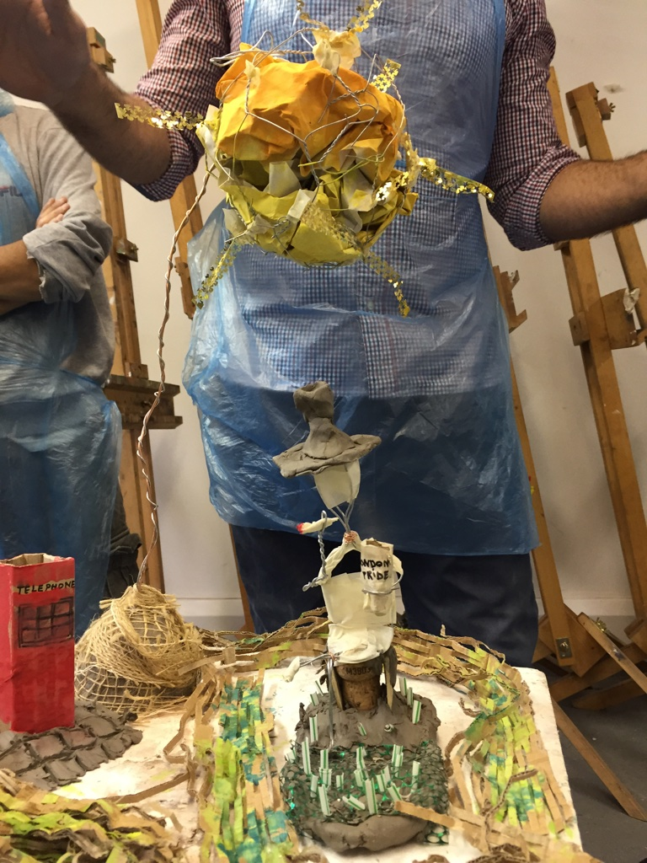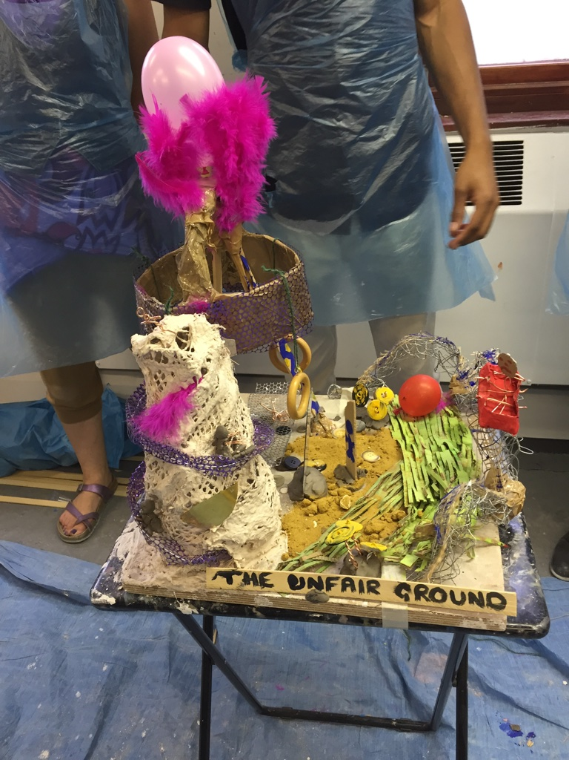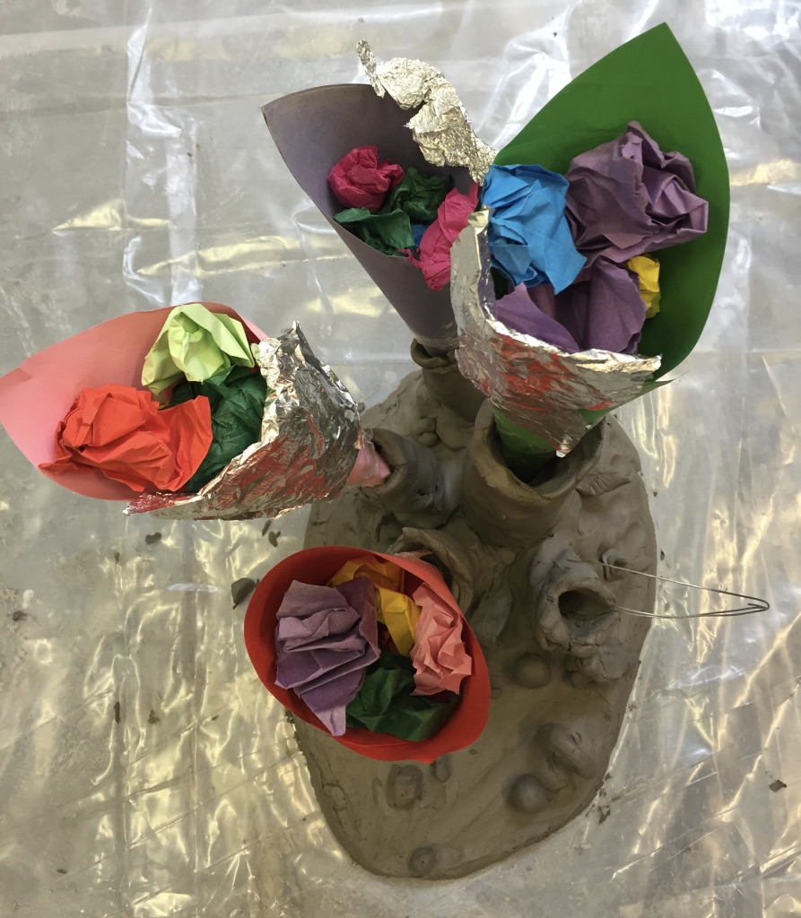

Frieze/mural painting
This exercise encourages students to explore their creative imagination whilst being able to have fun working together and getting to know each other. The team starts by learning about abstract painting and collage, they then learn techniques themselves by doing some simple exercises based on abstract principles. The tutor takes them through the exercise step by step, so no previous experience or aptitude is required. The group is given a story, poem or piece of music, which they have to depict in one complete frieze on paper around the walls, or on the floor of the room. The group is divided into teams, each responsible for portraying one chapter of the story. Participants will have a wide array of instruments (brushes, sponges, bamboo etc), paints, inks, found objects and collage materials.

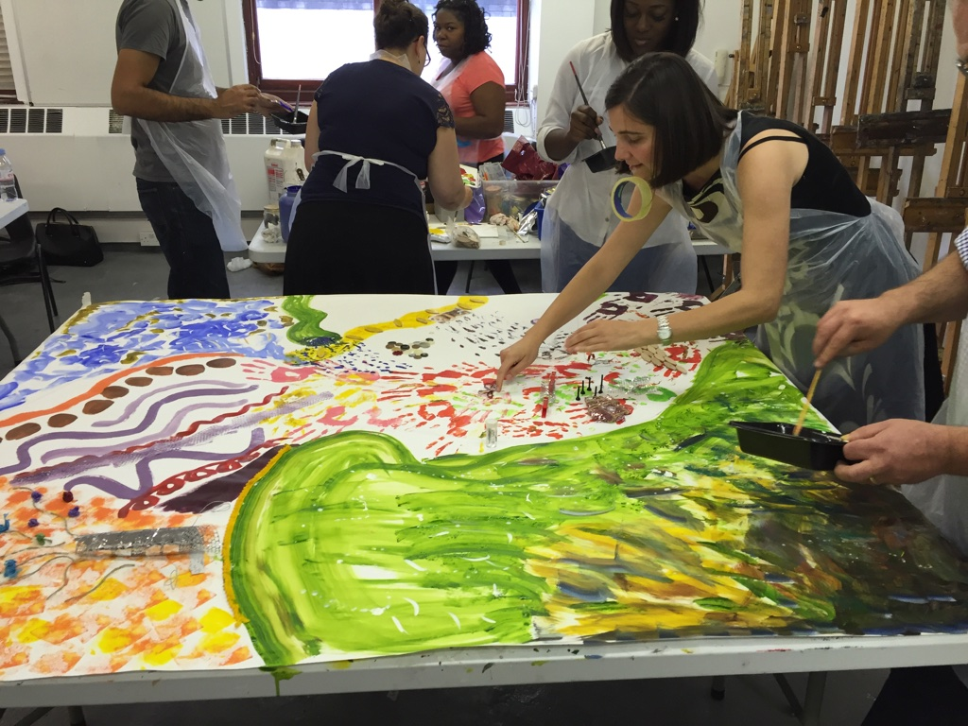
Art United
Ideal for exploring and improving communication, time management and team cohesion. May teams have to develop strategies for working in subgroups and adhoc working parties, and this exercise encourages effective collaborative working. The overall aim is to create a large picture based on a theme or poem that is given to the whole group at the start. The exercise relies entirely on everyone communicating clearly and consistently, and is therefore a great exercise in getting everyone to mix, communicate and unite towards a common goal. Participants will have a wide array of instruments (brushes, sponges, bamboo etc), paints, inks, found objects and collage materials to works with.

Transmission
Creative objective: The team is divided into groups, with each group responsible for drawing part of an overall image onto the wall. At first this may sound easy, but the team members who are drawing are blindfolded, taking instruction from a communicator… who is told what do by their team leader… who is the only one with the image.
Training objectives: The aim is to complete the task and ensure that each member feels empowered and valued as part of the team. Participants’ skills of communication, listening and awareness are put to the test in this challenging exercise, which reflects the piecemeal nature of much communication in organisations and offers participants an opportunity to explore more effective and positive approaches.

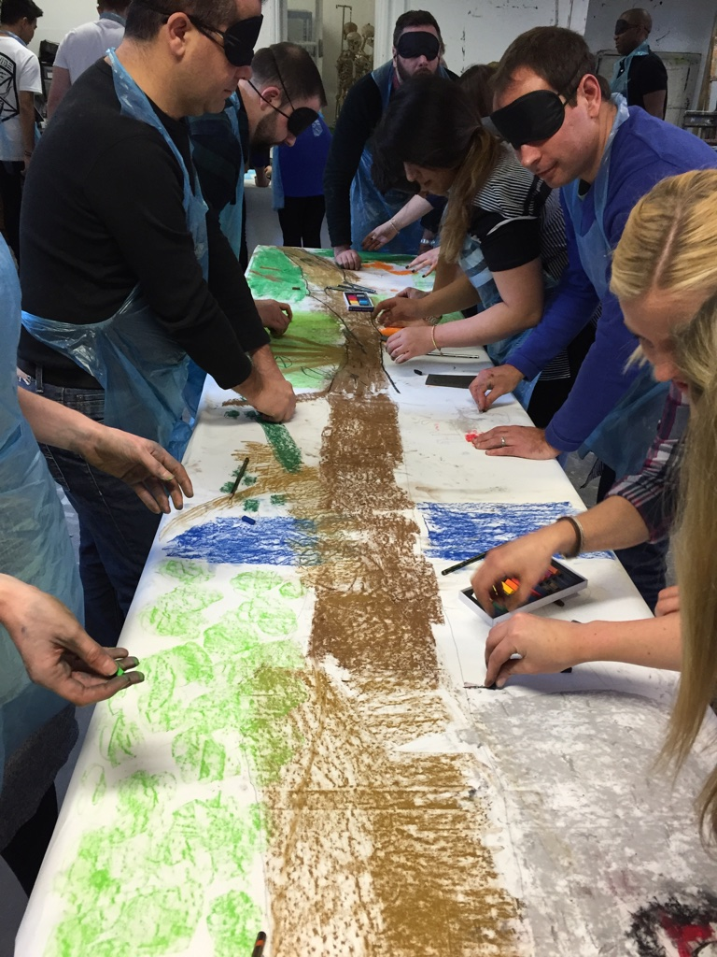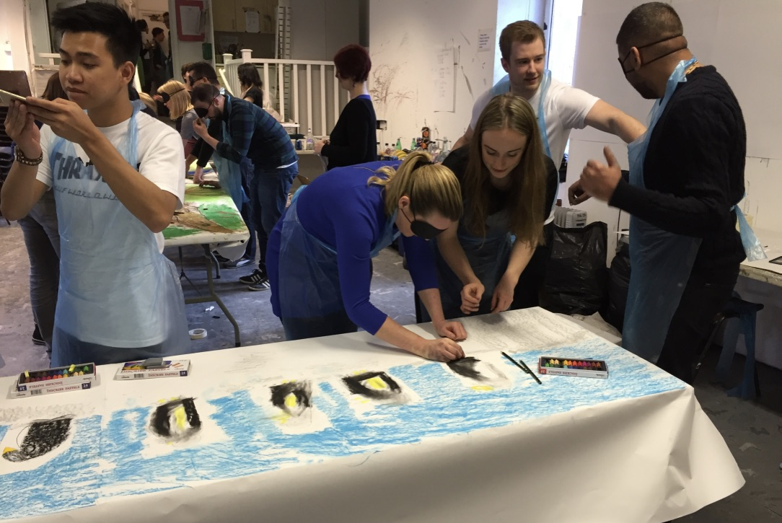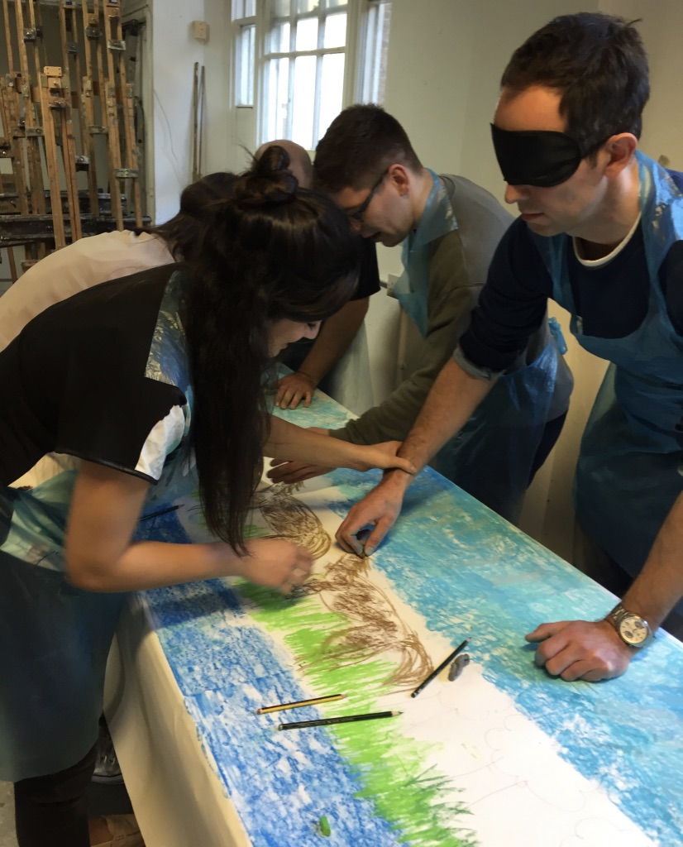

BESPOKE
Bespoke workshops are created especially for the needs of your group or team – to produce unique specific results targeted for a particular outcome.
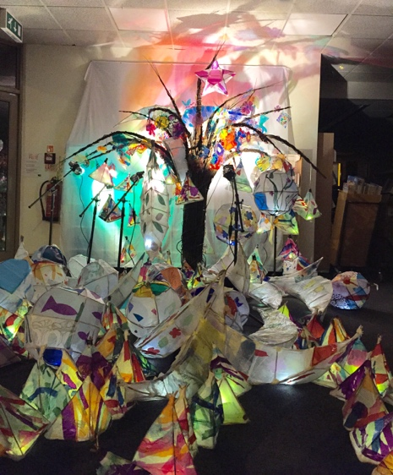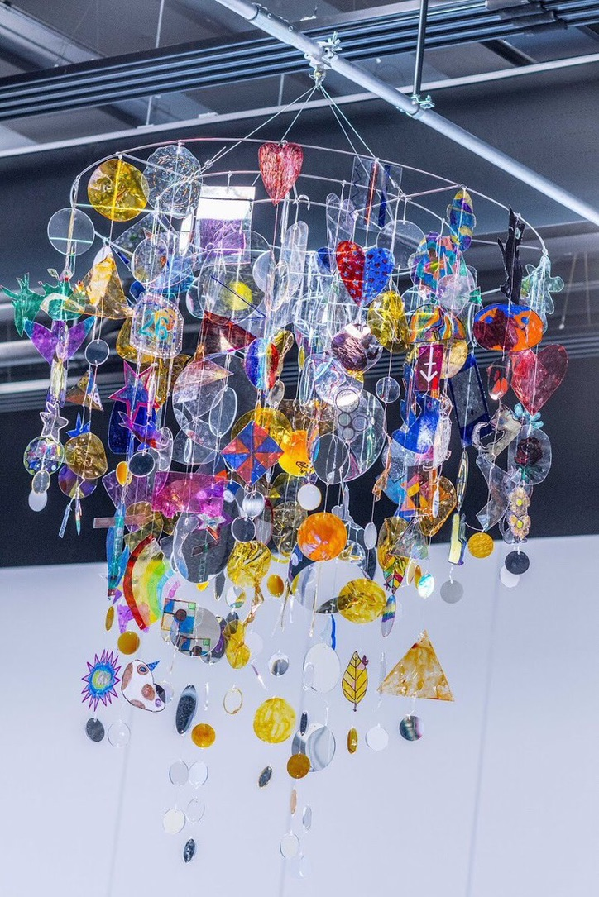
Warm Up Games

The Newspaper Game
Using a huge pile of newspapers, scissors and Sellotape, each team chooses a film to depict and has 20 minutes to create a 3D sculpture as big and crazy as they want, from dinosaurs and flying alien spaceships to towering infernos (not actually alight!); this is a wonderfully creative way to have a lot of fun.

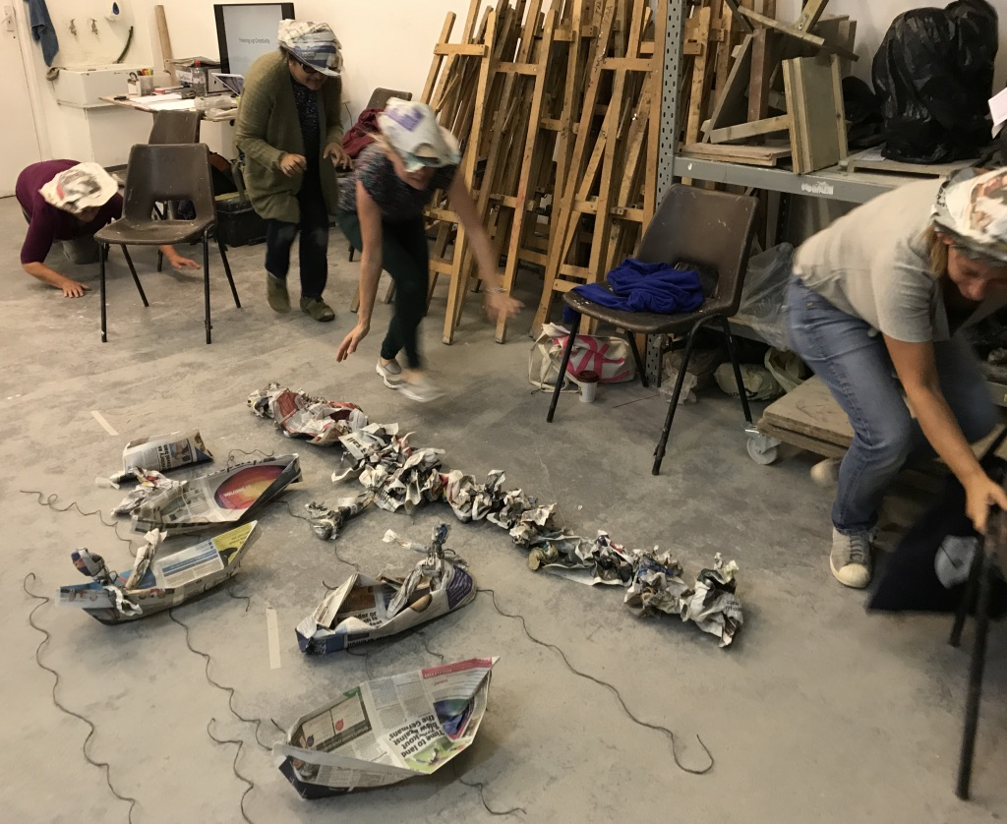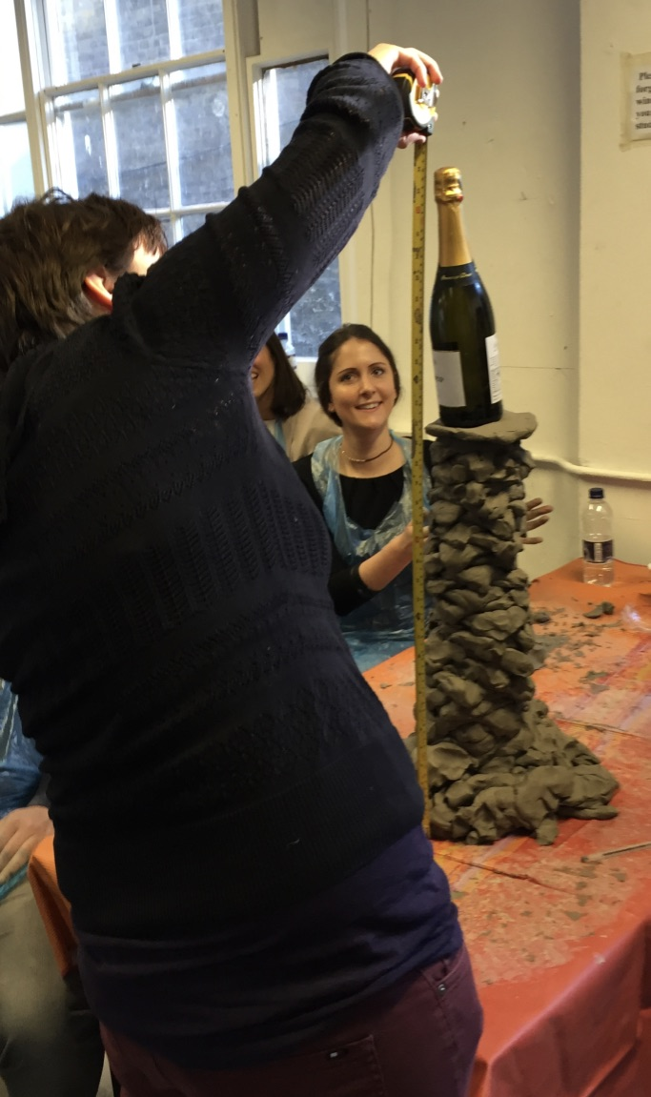

Giant clay sculpture
This exercise is immense fun and very creative, as everyone is working together. The group is given lots of clay, wire and paper and a large amount of floor or table space. They are given a theme: a farmyard, London in 3000AD the seabed, an alien planet, or another theme if appropriate. They then literally get on with it, all together, in a very spontaneous, creative way. They are encouraged to use the whole space to create one large sculpture and be as imaginative as they like. It is wonderful watching everyone interacting and the sculpture emerging.

Tottering Towers
In teams, it is a race to build the tallest tower out of the same amount of clay per
team. Ingenuity, teamwork and strategy are put to the test in this fun game. A great
(and mess free) variant of this game involves building towers out of newspaper and
rubber bands.

The Memory Game
How much can you remember about a set of images or tray of objects … and how
accurately can you draw, paint or sculpt them in a few minutes.

The Adverts Game
Each group is given the name of a film, book, play or event and has 20 minutes to create a collage that best advertises it using words and images from a pile of newspapers and magazines. Everyone’s powers of imagination are extraordinary, and the results are often hilarious. You could even have a prize for the best effort.

Shaggy Dog
A hugely entertaining warmup that will get everyone going both visually and verbally.
Everyone has to draw an image – anything will do, and no conferring is allowed. The images are then spread out on the floor or held by each person for the others to see and from this seemingly random group of pictures a story must emerge. Hilarious and surreal, but also an excellent way to start a workshop. Particularly good for large groups.

Make an Impression
A really original warmup, ideal for getting everyone to communicate. Everyone gets to quickly create small sculptures that express their feelings about each other in a positive way, working their way from person to person

Beauty Pageant
In groups, each team will have a heap of paper, material, scissors and tape. It is a contest to see who can dress their contestant in the most creative costume based on the theme chosen.

Arts Race
A 3D guessing game – the group will race against the clock to complete the cards, which have to be drawn, sculpted or mimed. This icebreaker is great fun and gets people being creative without worrying about achieving ‘perfect’ results.

Reconstruction
The group has to create a coherent story from a set of sequential pictures. The pictures are randomly shuffled and handed out (if there are more pictures than people, some or all may get more than one.) People can not show their picture to others, but must work together to make sense of the original story. This requires a lot of patience, communication, and an effort to understand things from another’s point of view.

